## NOTE: phones may be connected to your data connection or they may be connected with a separate data connection – If your computer is connected to the same connection as the phone, your phone is connected to the wall jack and your computer is then connected to the back of the phone. If your computer reboots, your phone stays up. Most phones will require a power supply, if the power is out, so is your phone. If you are connected via USB (headset or speakerphone) to your computer and your computer reboots, so does your phone.

## **If you order a USB phone or headset, your computer MUST be on and Skype for Business operating (logged in, occurs automatically on computer start-up) to place a call. This includes E911 calls. You may call from a cell phone if you have one but we want faculty and staff to be aware of this limitation so you can choose the appropriate device.

You may order your own headset from the vendor of your choice either on the Marketplace or via Pcard. For the best quality please choose a headset that says it is compatible with Microsoft Lync or Skype for Business.

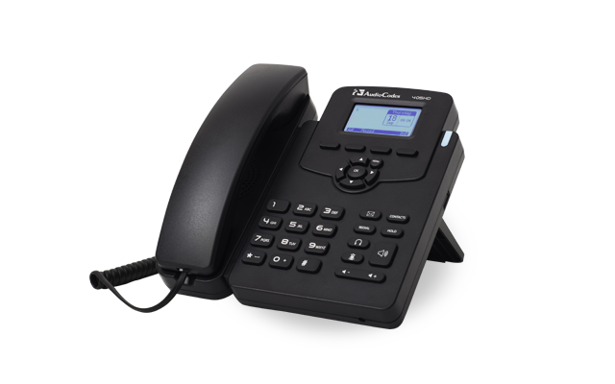

We are currently offering the **Audiocodes 405HD** phone if you choose a phone set. Approx $113.

This phone will be plugged into a data jack (and your computer may be plugged into the back of this phone). The phone will always be on as long as it has power (even if your computer is off).

**We also offer these USB phones:**

[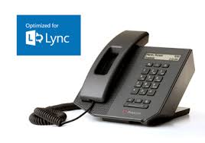](http://www.google.com/imgres?imgurl=http://www.polycom.com/content/dam/polycom/www/images/products/microsoft/cx300-lg-a.png&imgrefurl=http://www.polycom.com/products-services/products-for-microsoft/lync-optimized/cx300-desktop-phone.html&h=260&w=370&tbnid=v8z63R9oABpbYM:&zoom=1&docid=dIYC1YL6BWPwyM&ei=8gxRVNznE8esogTju4GYBA&tbm=isch&ved=0CC4QMygAMAA&iact=rc&uact=3&dur=974&page=1&start=0&ndsp=20)**Polycom CX300 USB phone – Approx $210.** Connects via USB to your PC or laptop. You simply plug the phone via USB to the computer. You need to be logged into Skype on your computer for the phone to work. If your computer is turned off, the phone will not work. If you are not signed into Skype, the phone will prompt you to “sign into Microsoft Skype”. It is a full duplex speakerphone. You can dial from your Skype client and pick up the call with the phone.

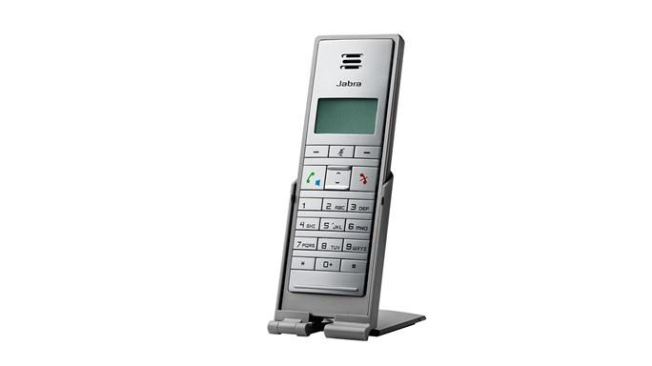

**Jabra Dial 550 USB Handset - Approx $54. -** Connects via USB to computer, it delivers standard handset features, familiar functionality and comes with a handy flip stand that keeps your handset nearby and protects it when you are on the go. You can hear incoming calls when your computer is locked or muted. You can access and join conference calls whenever you want and wherever you are. Use the Jabra Dial 550 handset as a speakerphone with just the touch of a button.