Some recommended headsets for Skype for Business.
Note: There are hundreds of headsets, you may choose a different one that you like, just make sure it says it is Skype or Lync compatible (usually the MS in the name indicates that it is compatible). Most headsets are available on the Marketplace. Some are available from multiple vendors, be sure to check for the best price.
Remember: for Wireless headsets, you will at some point need to order more batteries for it. They should last at least a year. You may also want to make sure there is a spare corded headset in case someone needs one.
Plantronics Savi W445-M - Wireless headset – Approx $210 – Gov Connect has the best price (last I checked)
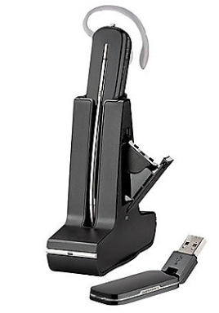
Sennheiser MB660 MS – Wireless Bluetooth – noise cancelling – approx. $350
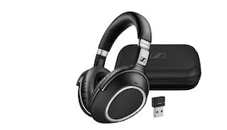
Sennheiser MB Pro2 ML - Wireless – approx. $200
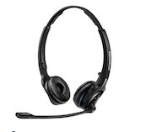
Sennheiser MB Pro1 ML – Wireless – approx. $180
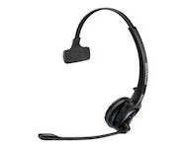
Sennheiser SC60 – Corded headset approx. $35.
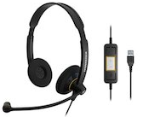
Jabra Evolve 20 MS – Corded headset approx. $20
